
Symbiosis Institute of Technology, Pune
Faculty of Engineering
CSE- Academic Year 2026-27
Java Programming – Lab Batch 2024-28
Lab Assignment No:- 16
Name of Student | Aarushi Raizada
PRN No. | 25070122002
Batch | 2025-29
Class | A1
Academic Year & Semester | 2026 Sem III
Date of Submission | 20th August’26
Title of Assignment: | Write a Java program to demonstrate the use of Swing and Applets
Theory  Practice questions | Swing is Java's GUI toolkit that provides lightweight components such as buttons, labels, text fields,  and menus. Applets were small Java programs embedded in web pages for interactive applications.  Although Applets are obsolete, Swing remains an important framework for desktop application  development. Swing supports platform-independent graphical interfaces.  1. Create a simple Student Registration Form GUI using Swing.  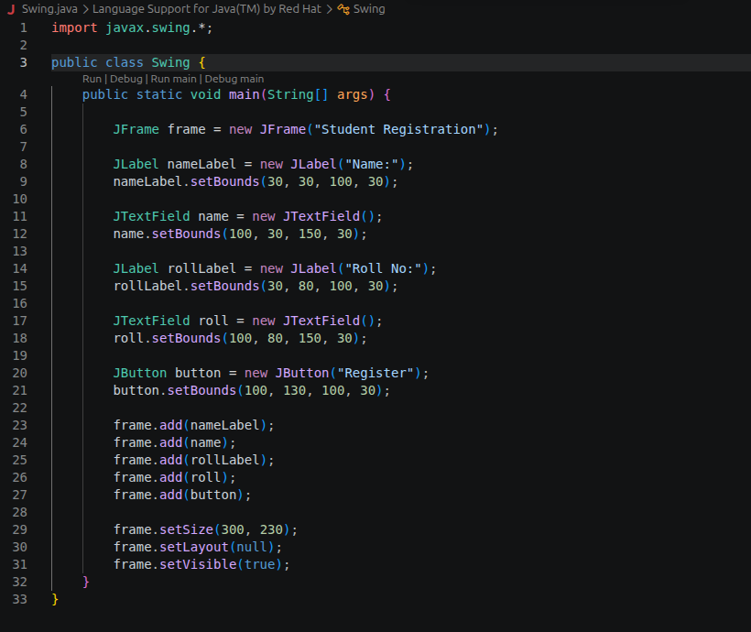  2. Create a simple Employee Registration Form using Java Swing GUI that takes employee  details such as Employee ID, Name, Department, and Salary. Display the entered  information in a dialog box  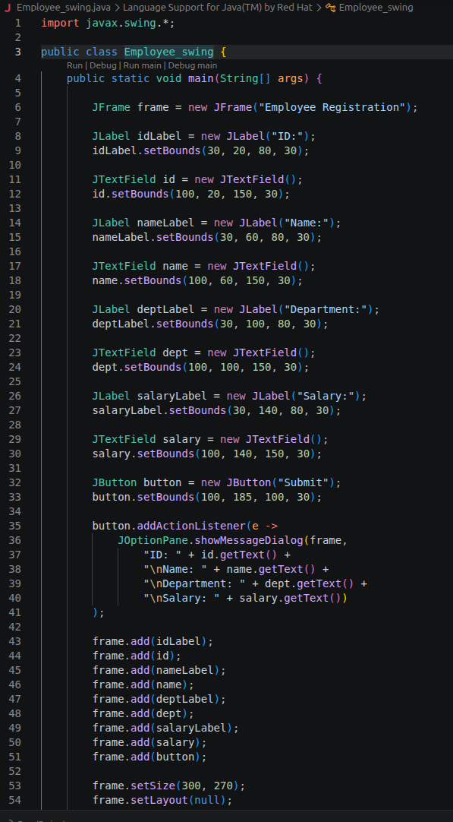
Output Screenshots (if applicable) | Ans 1  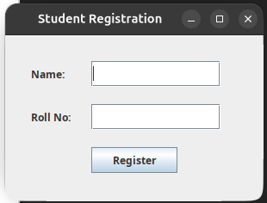  Ans 2  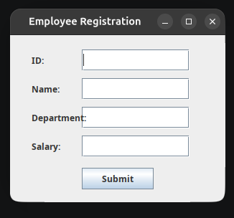
Conclusion | Thus, the Student Registration Form and Employee Registration Form were successfully created using Java Swing. The programs accept user details through GUI components and display the entered information using a dialog box.

